**Accessing and Using the Sky Brightness Survey**

Simon Bilsky-Rollins

August 4, 2016

Step 1: Download Survey123

1. Go to your phone’s App Store or Play Store and search for Survey123. You should see a free app called “Survey123 for ArcGIS” with a green icon:
2. Download the app onto your phone.

Step 2: Sign in to your ArcGIS Online account

1. Once it has finished installing, open up the Survey123 app on your phone and click the “Sign In” button.
2. 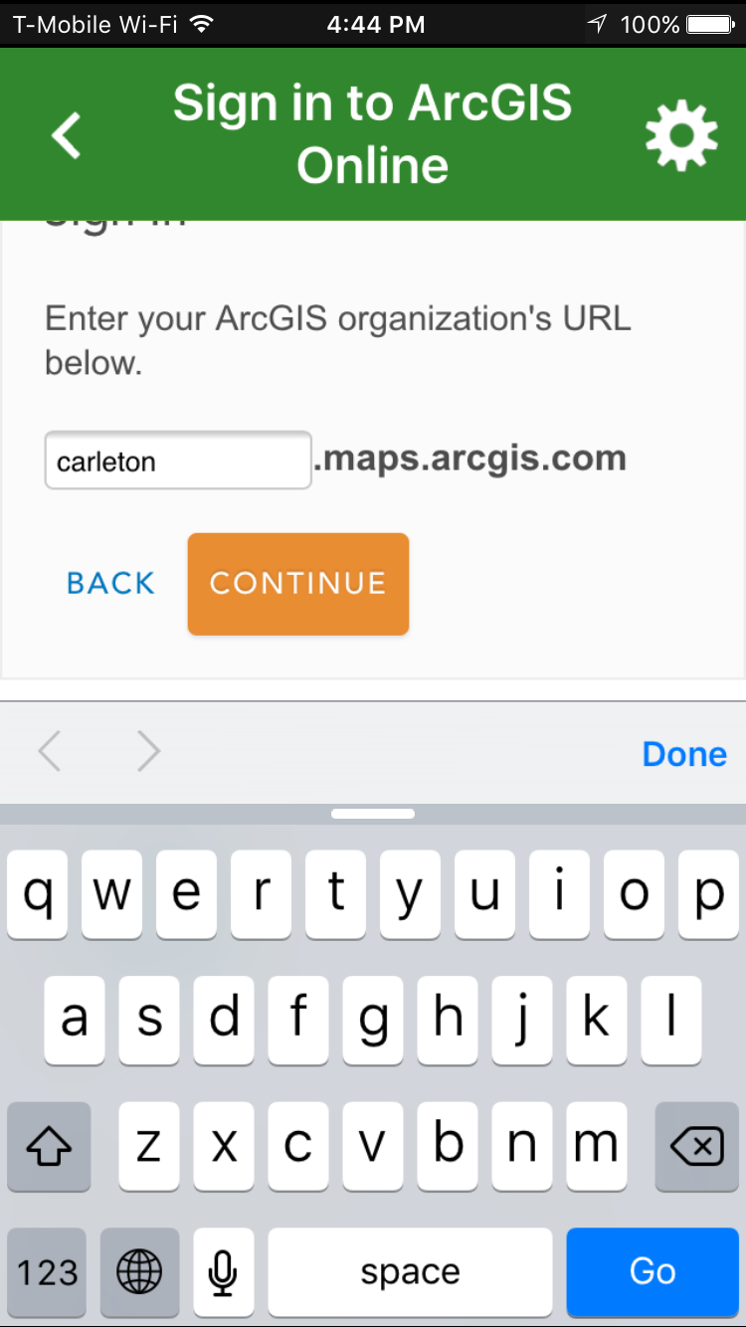Instead of signing in at the first page you’re presented with, click the “Enterprise Account” button below the sign in form.
3. 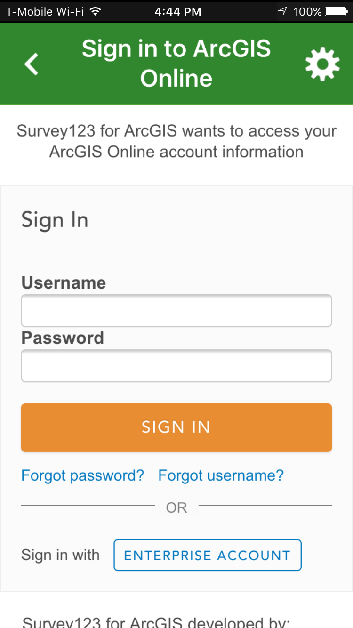Type “carleton” in the organization URL field, then tap “Continue.”
4. On the next screen, choose “Using your Carleton College account.”
5. Sign in using your Carleton username and password.

Step 3. Download the Sky Brightness Survey

1. Next, you should see the SkyBrightness survey available for download. Tap the download button to download it to your phone.
2. Press the back arrow to go to the main screen of the app, where you will see the survey you just downloaded.

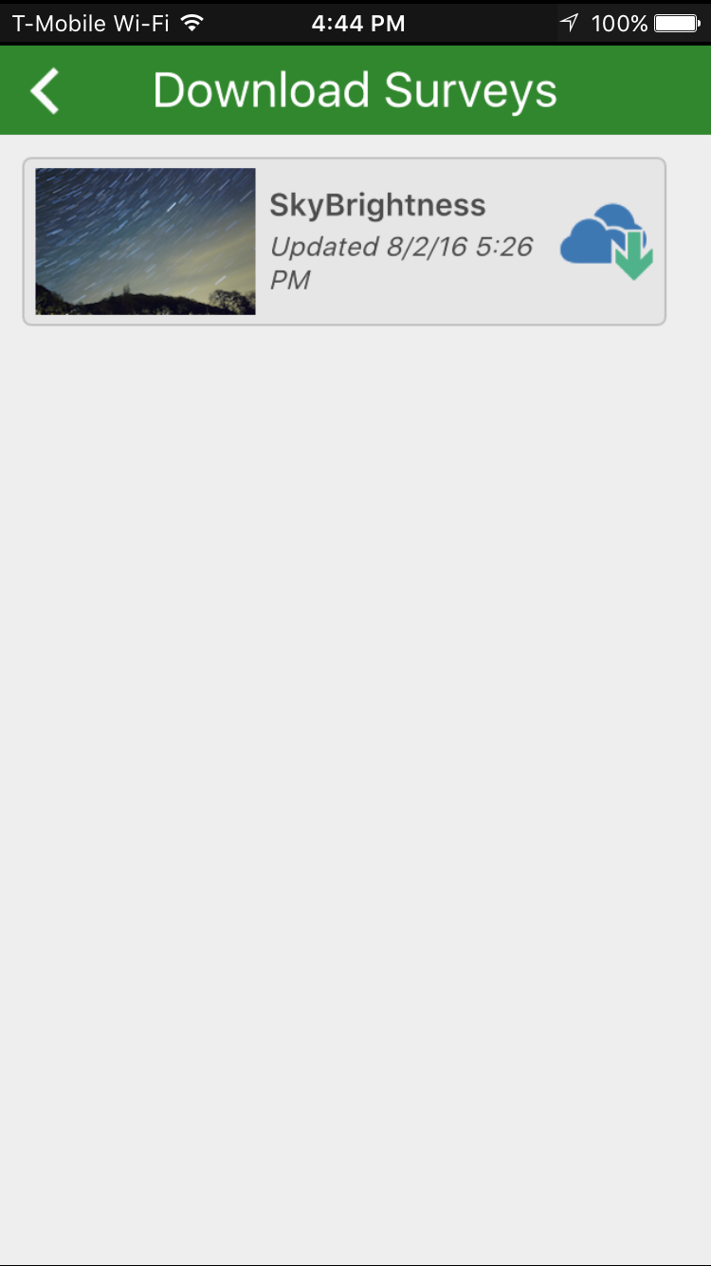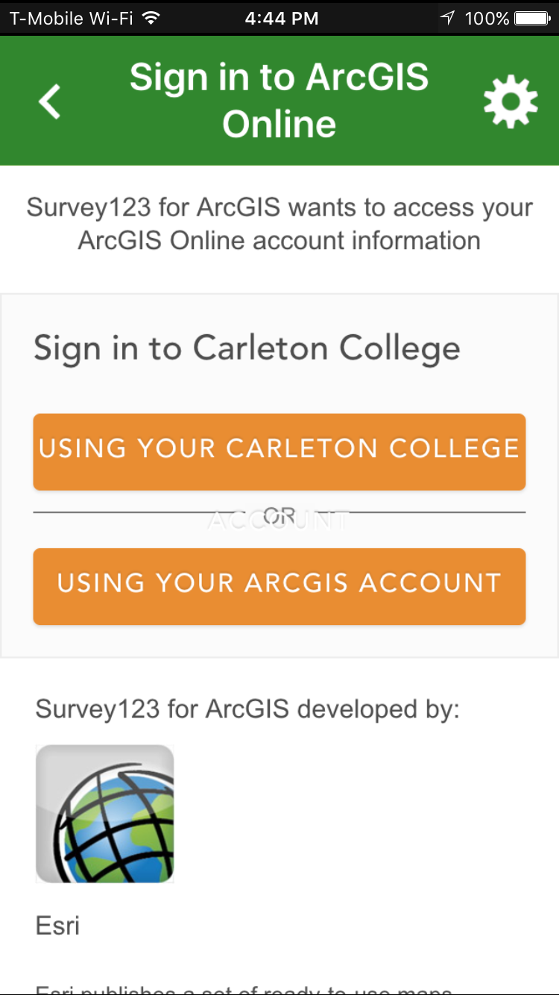

Step 4. Collect data with the survey

1. 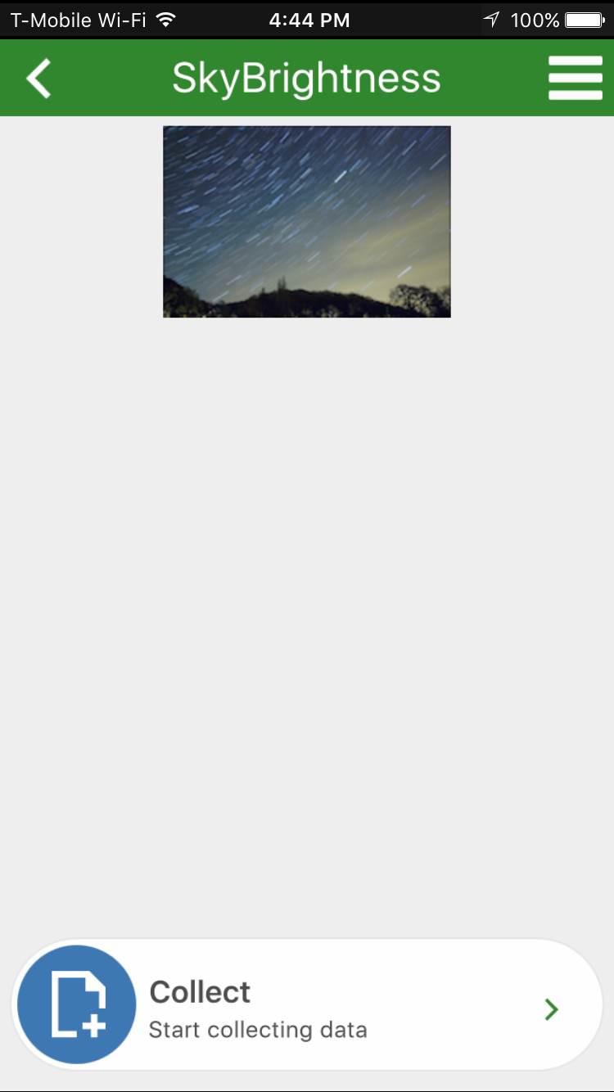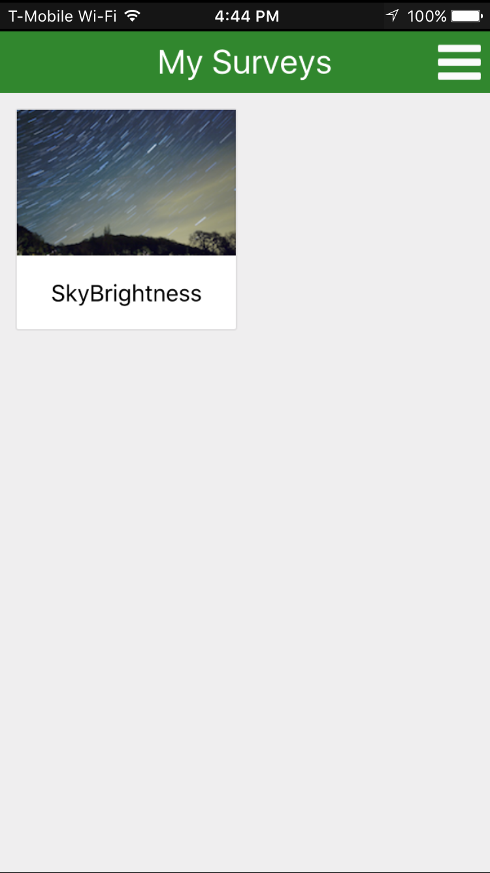Tap on the SkyBrightness survey, and then the “Collect” button to start collecting data using the survey.
2. If you are logged in with your own Carleton account, then you can ignore the “Meter Operator” field.
3. 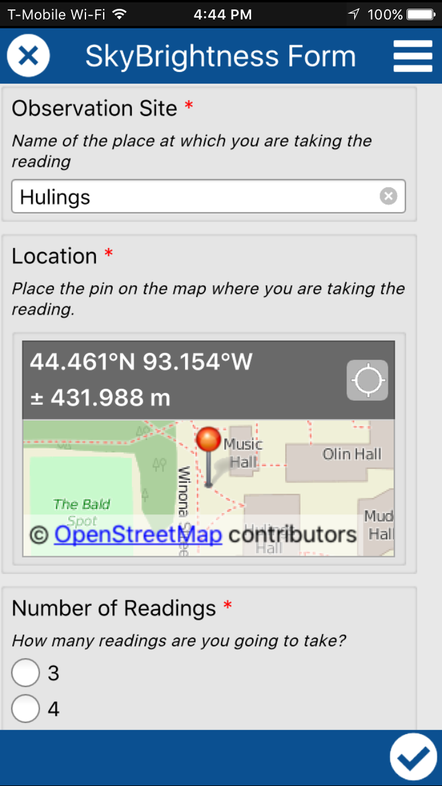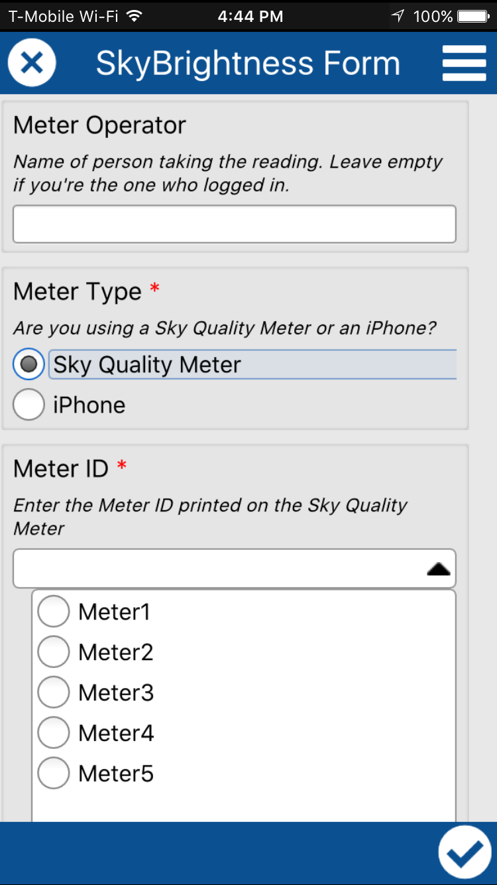If you are using a sky quality meter to take measurements, choose that option and then choose the correct meter from the drop-down menu that appears. Otherwise, choose “iPhone.”
4. The location field is automatically set to the location reported by your phone’s GPS. However, your phone’s GPS is not always reliable. For instance, in the example above, you can see that the error is ±431.988m. To manually adjust the location of the pin, tap on the map and pan and/or zoom to the correct location. You can use the button with the home icon to put the pin in the middle of the bald spot. Be sure to tap the checkmark in the lower right to save your location. If you press the back arrow instead, the location you specified will NOT be saved.
5. 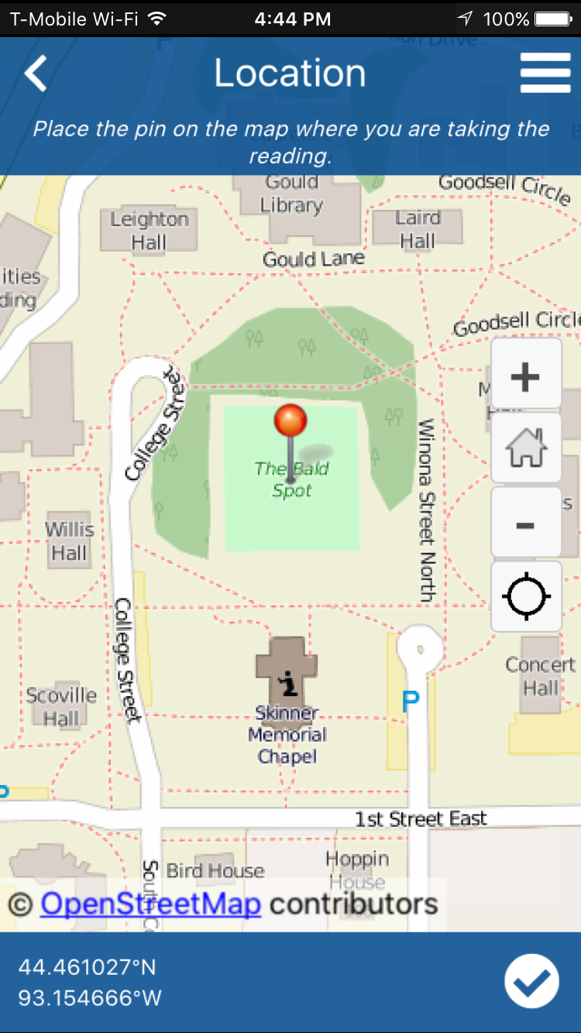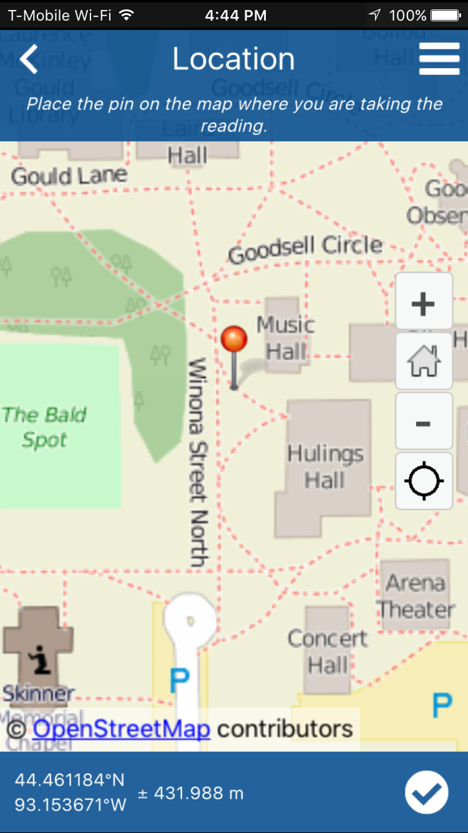Next, choose the number of readings you are going to take. If you choose 4 or 5, additional meter reading fields will appear for you to fill in.
6. Take measurements and then fill in each meter reading field.
7. 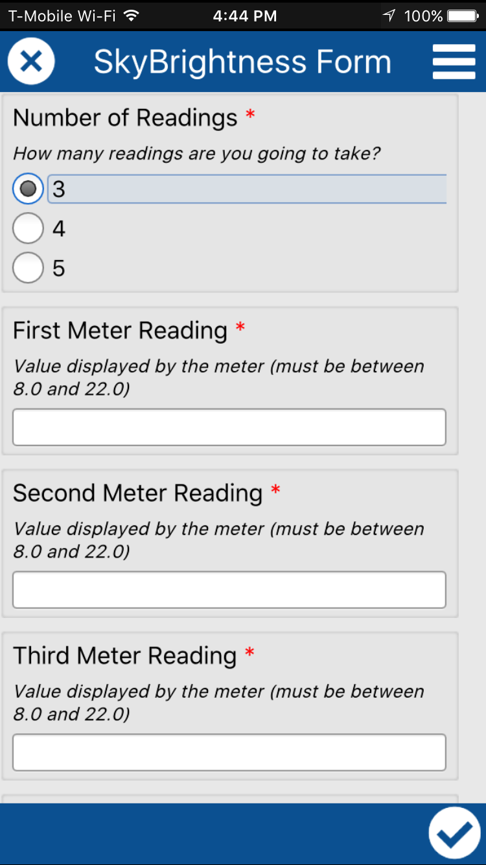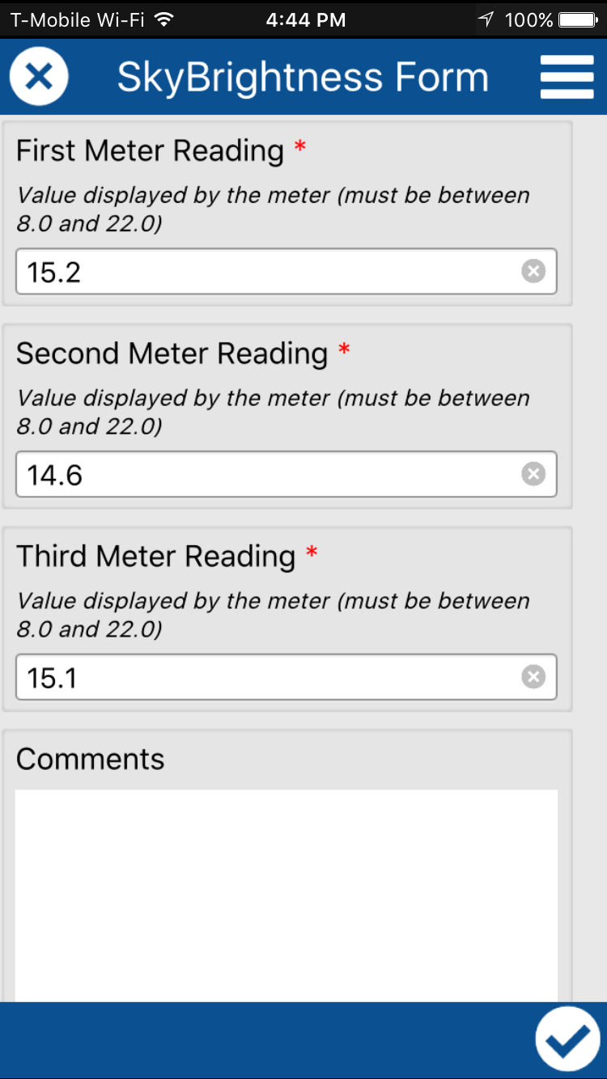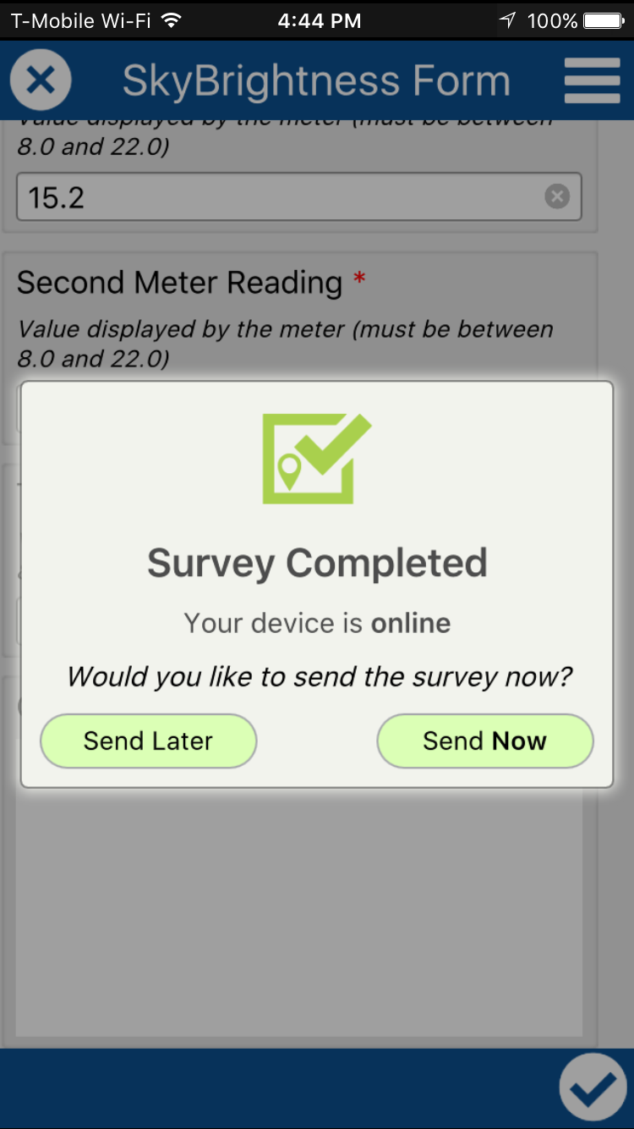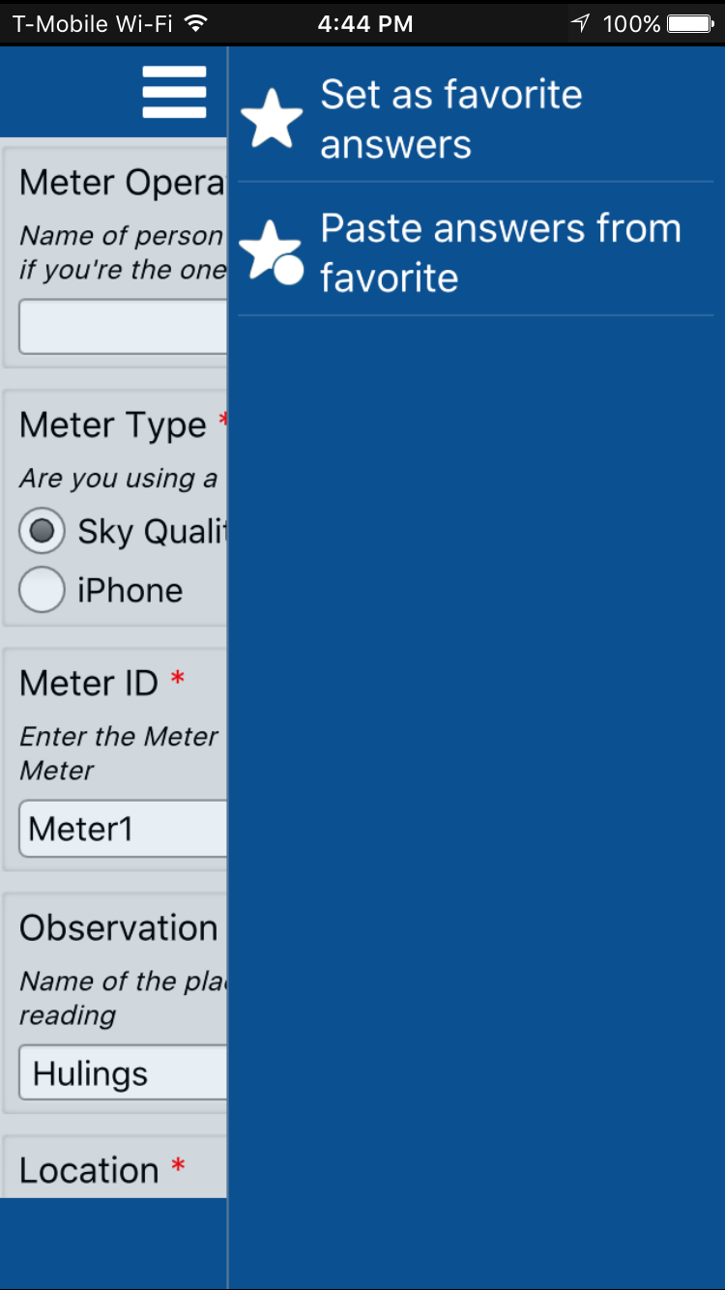You may want to save a set of “favorite” responses that you can reuse in the future. To do this, tap the menu button in the top right corner and select “Set as favorite answers.” Then, when you fill out a new survey, you can find the “Paste answers from favorite” option in the same menu.
8. Finally, enter any comments you may, and tap the checkmark to save your responses. If you don’t have a good Internet connection while you’re filling out the form, you can choose the “Send Later” option. This will save your responses on your phone and allow you to upload them later.

Step 5: Uploading and editing responses

1. You can see all the responses you’ve made to the sky brightness survey by tapping “Outbox” or “Sent.” From there, you can tap on a particular response to edit it, and if you need to upload responses that you’ve saved for later, you can tap the “Send Surveys” button at the bottom of the screen.
2. 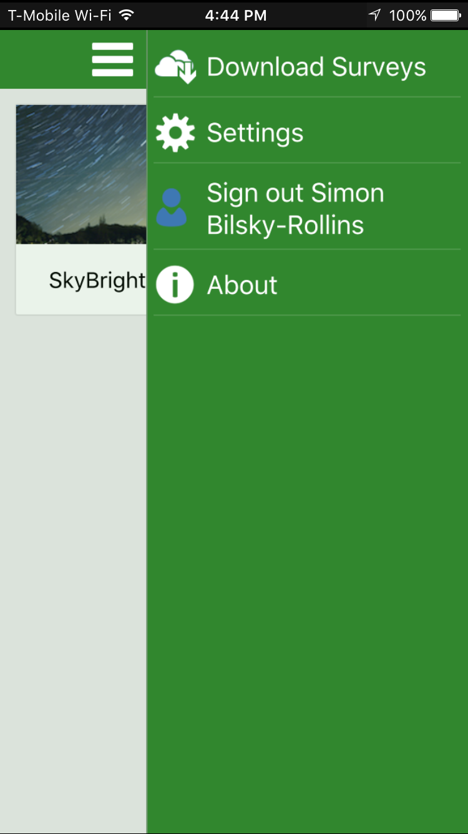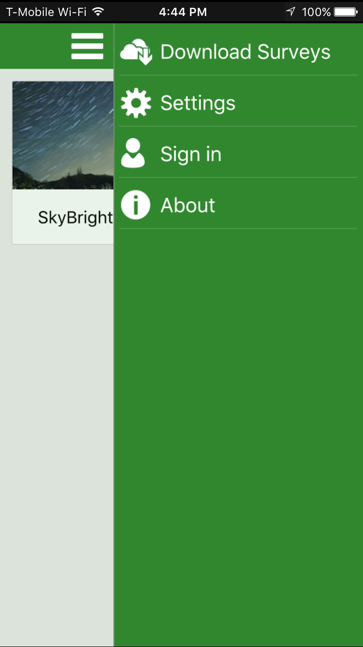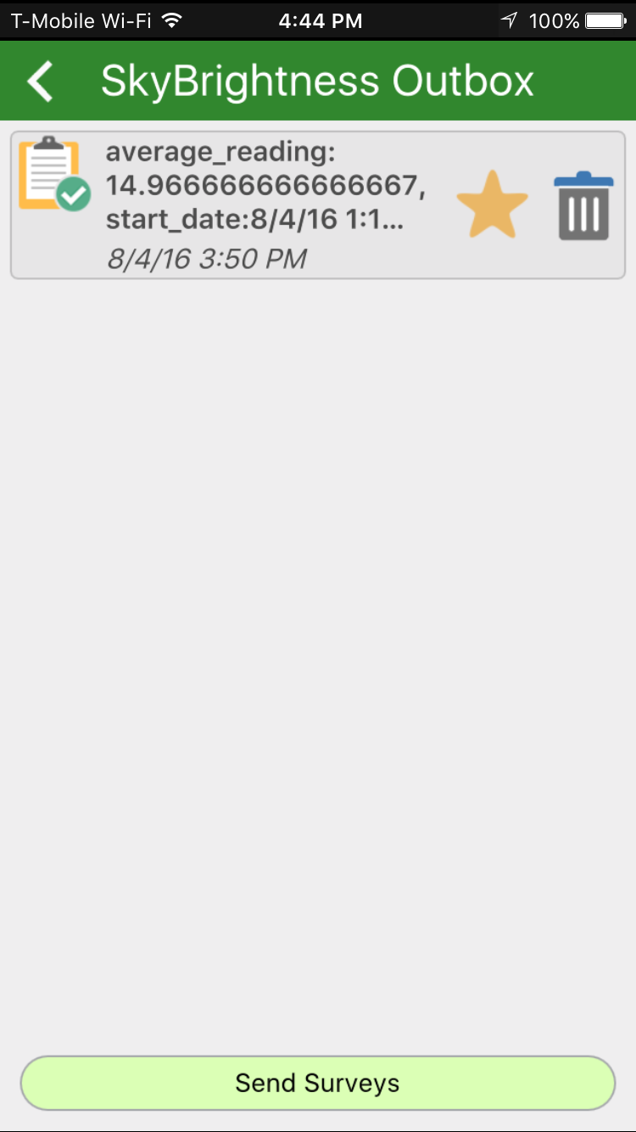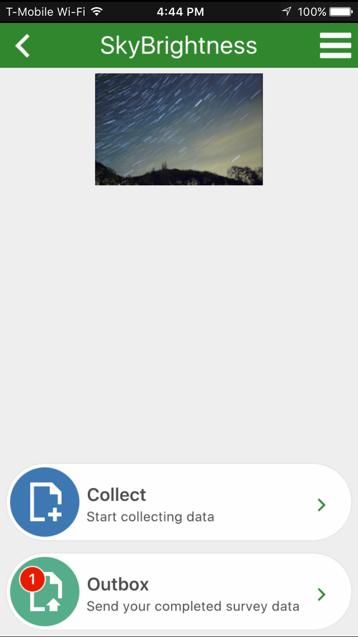If you get an “invalid token” error while uploading your responses, you need to sign out of your ArcGIS Online account, sign back in, and then try uploading your responses again. To sign out, go back to the main screen of the app, tap the menu icon in the top right, and tap “Sign out.” Then go back to that menu, tap “Sign in,” and follow the earlier instructions on signing in.